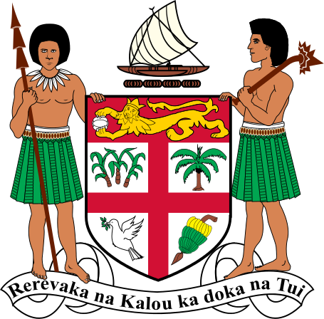
MINISTRY OF ENVIRONMENT AND CLIMATE CHANGE
TWO VACANCIES: PACIFIC EARLY CAREER OCEAN PROFESSIONAL (ECOP) FELLOWS
The Ministry of Environment and Climate Change, in partnership with the Pacific Community (SPC), invites applications from recent Fijian graduates for two 12-month, full-time ECOP Fellowships with the Oceans Unit, Department of Climate Change, in Suva.

About the Placement
The fellows will support Fiji’s National Ocean Policy through secretariat and administrative work, policy research, stakeholder consultations, communications and regional coordination. The placement includes mentorship from the Ministry and SPC, with opportunities for professional development and Pacific ECOP networking.

Eligibility
- Fijian citizen aged 18–35 at the commencement of the placement.
- Bachelor’s degree or higher obtained within the previous 24 months in Marine Science, Environmental Science, Climate Change, Ocean Governance, Environmental Law or a closely related field.
- Strong communication, research, organisational and computer skills; relevant volunteer or work experience is an advantage.

How to Apply
Submit your CV, academic transcripts, Expression of Interest (EOI) and completed job application form available through the Fiji Climate Change Portal (Careers) to Manager Human Resources at rosy.lata@environment.gov.fj.
Closing date: 30 October 2026
Both 12-month placements are funded and supported by SPC.

